Index #: 2.07
Page 9 of 11
I
~ Subject: Americans with Disabilities Act
PUBLIC NOTICE
The Americans with Disabilities Act prohibits discrimination against any qualified
individual with a disability. The Tennessee Judicial Branch does not permit
discrimination against any individual on the basis of physical or mental disability
in accessing its judicial programs. In accordance with the Americans with
Disabilities Act, if necessary, the Tennessee Judicial Branch will provide
reasonable modifications in order to access all of its programs, services and
activities to qualified individuals with disabilities.
If you require a modification to access the judicial program and/or have special
needs because of a qualified disability, you must submit a written Request for
Modification to the Local Judicial Program ADA Coordinator listed below at least
five (5) business days prior to the date of the judicial program, if possible. A form
is available from the Local Judicial Program ADA Coordinator or from the
Tennessee Judicial Program ADA Coordinator.
If you need assistance, have questions or need additional information, please
contact your Local Judicial Program ADA Coordinator:
Kim Alsup – Judicial Program ADA Coordinator
201 Marshall County Courthouse
Lewisburg, TN 37091
Phone 931-359-2181 or Fax 931-359-0524
Kimberlee.alsup@tncourts.gov

If you need assistance, have questions or need additional information, you may
also contact the Tennessee Judicial Program ADA Coordinator:
ADA Coordinator

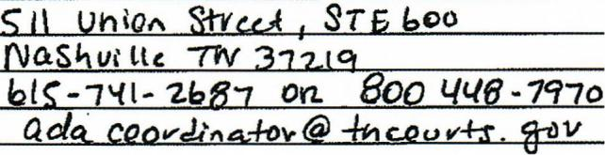
The Tennessee Judicial Branch Americans with Disabilities Act Policy
Regarding Access to Judicial Programs, as well as a Request for Modification
form may be found online at www.tncourts.gov.

OR
Marshall County TN ADA Coordinator
Don Nelson
3301 Courthouse Annex
Lewisburg, TN 37091
Phone: 931-359-0567
don.nelson@marshallcountytn.com

